In this lesson we are going to be downloading some video footage from the Internet and we are going to import it in our natron and then we will be applying some filters to it and we are gonna do some enhancing and just gonna go through some different option for cleaning up footage and making it look nicer so we are gonna grab this and from pixaboy.com

We will search videos where they will

We search water. The video we are going to use should have good skin tone(who knows)

That we can kind of clean up and make it look nicer so we choose below video

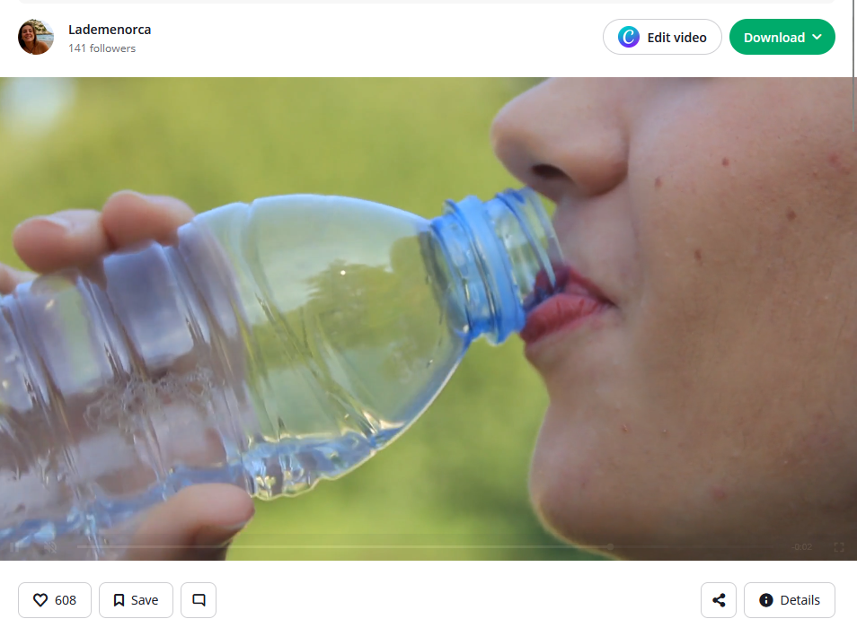

This is a great video to use in our project

Now we download it at 1920 X 1080 resolution so its full hd. Now we drag and drop the video to natron in node graph .Now node graph has a read node reading from the video Now it will look like below

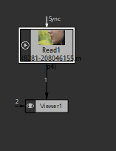

And we can read it indirectly So now we have our video we can play it its mp4 we are gonna notice have some artifacting

**Meaning:-**

**Artifacting** in video editing (or video processing) refers to **unwanted visual distortions** or **errors** that appear in a video, usually due to **compression**, **rendering issues**, or **hardware problems**.

There is some artifacting happening as shown below in Teacher not in mine (maybe becasue I have updated version of natron)

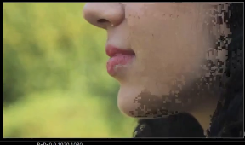

From what teacher van gather this happens because of the way natron reads in certain video files

Teacher think that its mp4 and the way natron reads it. In the first few frames it’s doing this artifacting it make it look kind of choppy and like these pixel are not displaying property within the rest of the video but it have some lingering artifacting

Teacher did some trick to correct (maybe I will do in future if I get stuck)Now we go to read node properties and then in list beside before feature as marked below

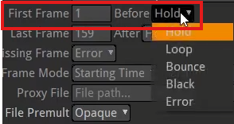

Change this hold to any other option Teacher change it to black it goes away as shown below

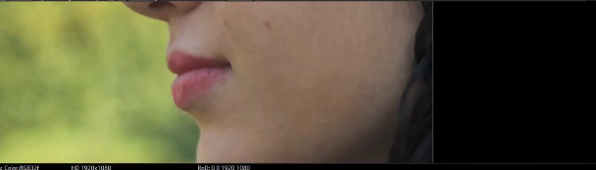

Noe even if we again choose Holf then this time it will not show any artifacting and now it should be good for the whole rest of the video

2:35